|  |
| --- |
| Sri Lanka Institute of Information Technology  BSc in Information Technology (Specialization in Interactive Media) |
| Game Design Document |
| “The Falling Red “ |
|  |
| **R.Y.N. Sirisena** |
| **IT-13-0380-38** |

**5/5/2015**

Contents

Overview 2

Introduction 2

Game Structure 3

Control 3

Scoring 3

Interface 3

Game Elements 4

Game Requirements 4

### Overview

## Introduction

This game is a game play of a ball falling from a cliff.

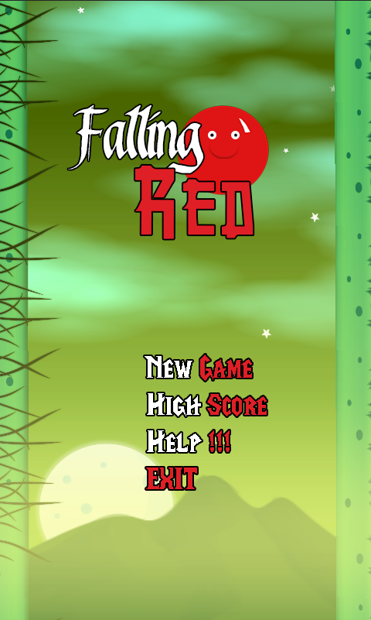

### Game Structure

# Control

The user gets a 2D interface. The main game character is a ball and gets many obstacles during the game. Touching the given interface helps the user to interact with the game. Surfaces can be drawn on screen and when the ball bounces on a particular surface the ball can be moved.

The user must be concerned with the characters health meter. In order to win the game the user must be able to withstand all tasks without finishing off players health. There are 3 hearts to indicate the amount of chances the player can hit an obstacle

# Scoring

Health Points and Life Count

At default the user gets 3X lives. If all the lives end the game ends too. You get upgrades during obstacles.

High Scores

The user gets a score from the beginning of game to the end. Scores depend on how long you survive in the game.

# Interface

The main menu

**New Game**: - By this you can start a new game from the beginning.

**High Score: -** By this you can view the best scores

**Help**: - This item helps the user to get any help regarding the gameplay

**Options**: - This item helps to manipulate the game in audio and visual components.

**Exit**: - This quits the game.

### Game Elements







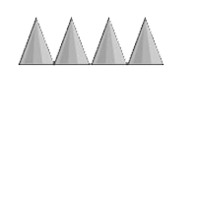

# Game Requirements

The supporting device should be

* Android
* Windows Phone